R Output
> library(NCStats)
> library(MASS)
> ss <- read.table("SalmonSperm.txt",head=T)
> str(ss)
`data.frame': 14 obs. of 3 variables:
$ step.len : num 2.48 2.94 3 3.02 3.17 3.18 3.2 3.27 3.31 3.66 ...
$ fert.succ: num 13.5 3 2.2 7 7 13.5 10.4 6.7 12.8 1.8 ...
$ mat : Factor w/ 2 levels "Adult","Parr": 1 2 2 1 2 1 1 1 1 ...
> attach(ss)
> xlbl <- "Sperm Tail End Piece Length (um)" # to save typing later
> ylbl <- "Fertilization Success"
> lm1 <- lm(fert.succ~step.len*mat)
> summary(lm1)
Call: lm(formula = fert.succ ~ step.len * mat)
Coefficients:
Estimate Std. Error t value Pr(>|t|)
(Intercept) -21.132 28.616 -0.738 0.477
step.len 10.560 8.684 1.216 0.252
matParr -63.570 48.730 -1.305 0.221
step.len:matParr 18.461 14.470 1.276 0.231

Residual standard error: 10.27 on 10 degrees of freedom
Multiple R-Squared: 0.4372, Adjusted R-squared: 0.2683
F-statistic: 2.589 on 3 and 10 DF, p-value: 0.1111

> confint(lm1)
2.5 % 97.5 %
(Intercept) -84.89158 42.62767
step.len -8.78769 29.90858
matParr -172.14816 45.00807
step.len:matParr -13.78023 50.70283

> anova(lm1)
Analysis of Variance Table
Response: fert.succ
Df Sum Sq Mean Sq F value Pr(>F)
step.len 1 636.61 636.61 6.0353 0.03387 *
mat 1 11.01 11.01 0.1044 0.75328
step.len:mat 1 171.69 171.69 1.6277 0.23086
Residuals 10 1054.82 105.48

> plot.fit(lm1,interval="c",xlab=xlbl,ylab=ylbl,pts=19)
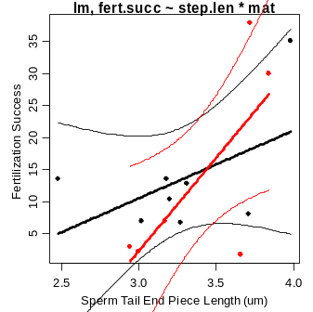

> nd <- data.frame(step.len=c(3,3.5),mat=c("Adult","Parr"))
> plot.predict(lm1,nd,interval="c")
obs step.len mat fit lwr upr
1 1 3.0 Adult 10.54938 0.9318293 20.16693
2 2 3.5 Parr 16.87409 7.0979373 26.65025
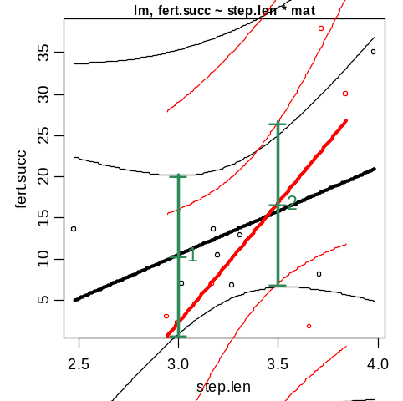

> lm2 <- lm(fert.succ~step.len+mat)
> anova(lm2)
Analysis of Variance Table
Response: fert.succ
Df Sum Sq Mean Sq F value Pr(>F)
step.len 1 636.61 636.61 5.7095 0.0359 *
mat 1 11.01 11.01 0.0988 0.7592
Residuals 11 1226.51 111.50

> lm3 <- lm(fert.succ~step.len)
> anova(lm3)
Analysis of Variance Table
Response: fert.succ
Df Sum Sq Mean Sq F value Pr(>F)
step.len 1 636.61 636.61 6.1731 0.02872 *
Residuals 12 1237.52 103.13

> anova(lm3,lm2,lm1)
Model 1: fert.succ ~ step.len
Model 2: fert.succ ~ step.len + mat
Model 3: fert.succ ~ step.len * mat
Res.Df RSS Df Sum of Sq F Pr(>F)
1 12 1237.52
2 11 1226.51 1 11.01 0.1044 0.7533
3 10 1054.82 1 171.69 1.6277 0.2309

> anova(lm3,lm1)
Model 1: fert.succ ~ step.len
Model 2: fert.succ ~ step.len * mat
Res.Df RSS Df Sum of Sq F Pr(>F)
1 12 1237.5
2 10 1054.8 2 182.7 0.866 0.4499

R Commands

library(NCStats)
library(MASS)
ss <- read.table("SalmonSperm.txt",head=T)
str(ss)
attach(ss)
xlbl <- "Sperm Tail End Piece Length (um)" # to save typing later
ylbl <- "Fertilization Success"
lm1 <- lm(fert.succ~step.len*mat)
summary(lm1)
confint(lm1)
anova(lm1)
plot.fit(lm1,interval="c",xlab=xlbl,ylab=ylbl,pts=19)
nd <- data.frame(step.len=c(3,3.5),mat=c(”Adult”,”Parr”))
plot.predict(lm1,nd,interval=”c”)

lm2 <- lm(fert.succ~step.len+mat)
anova(lm2)

lm3 <- lm(fert.succ~step.len)
anova(lm3)

anova(lm3,lm2,lm1)
anova(lm3,lm1)

